Apart from data model, we tried fitting other models based on other criteria too. Using logic as our, we tried to fit certain other interaction-effect models to observe the effect variables had on baby weight.

The other interaction - effect models tested were:

* **Parity** and **mother’s weight** against **baby weight**
* **Mother’s weight and income** against **baby weight**
* **Smoke and mother’s weight** against baby weight

These models were fitted and their AIC scores were for each were really high as compared to dataModel, hence they were not chosen for the final model selection.

AIC scores for the fitted models were:

* **Parity** and **mother’s weight** against **baby weight** = 10547.07
* **Mother’s weight and income** against **baby weight** = 9494.029
* **Smoke and mother’s weight** against **baby weight =** 10457.45

Although, on further testing we found some interesting results. Despite these AIC scores the models passed the model diagnostic tests.

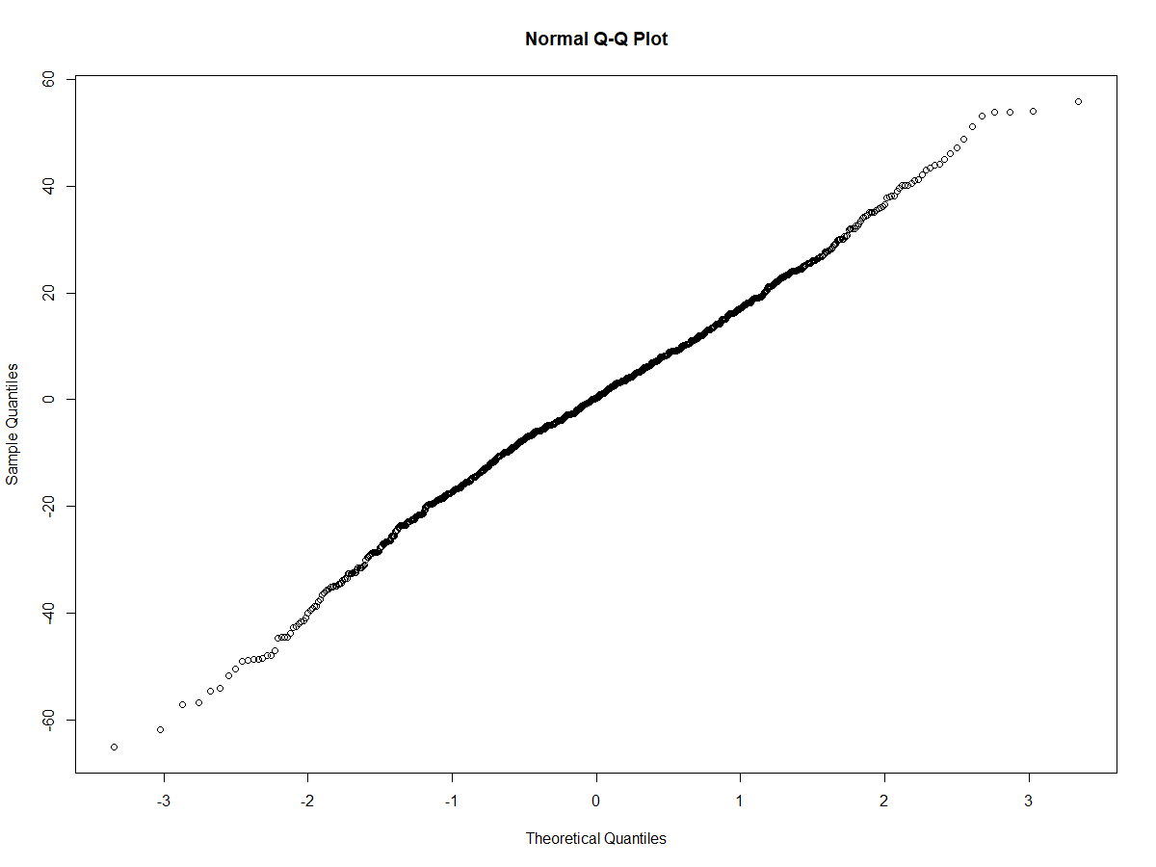

Normality test for the model – Smoke and mother’s weight against baby weight, passes the test.

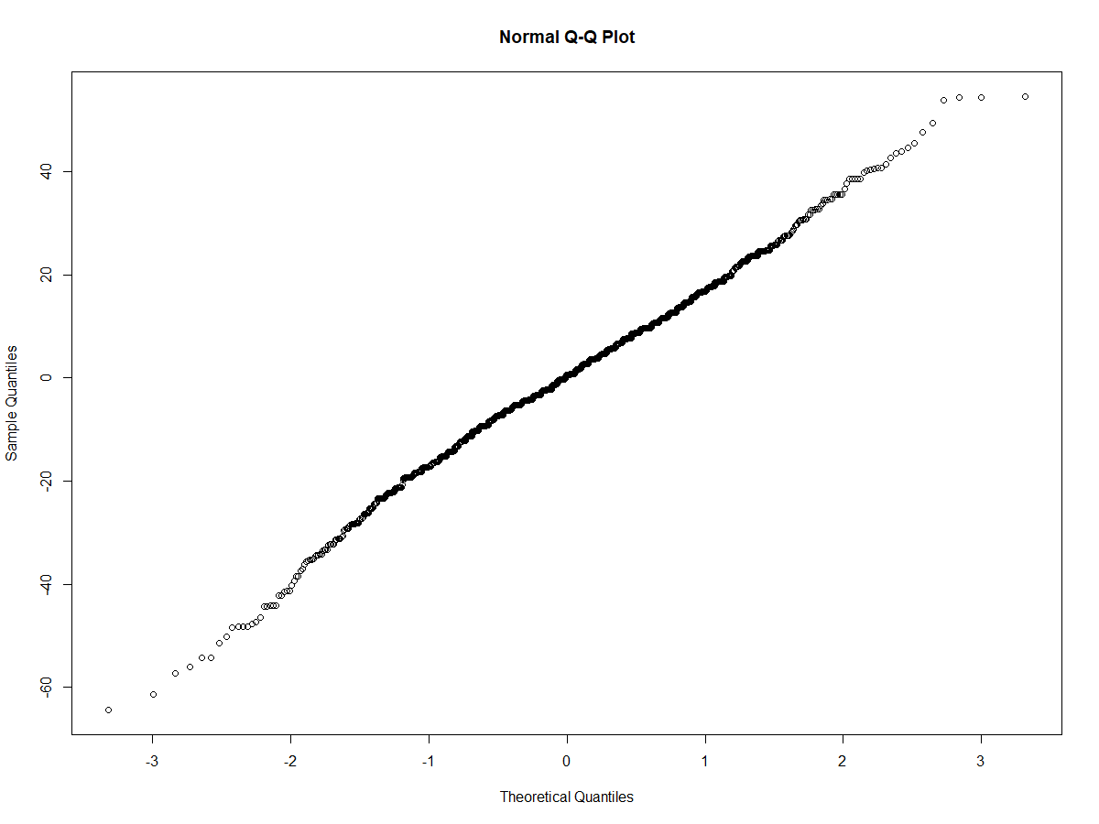

Normality test for the model – Income and mother’s weight against baby weight, passes the test.

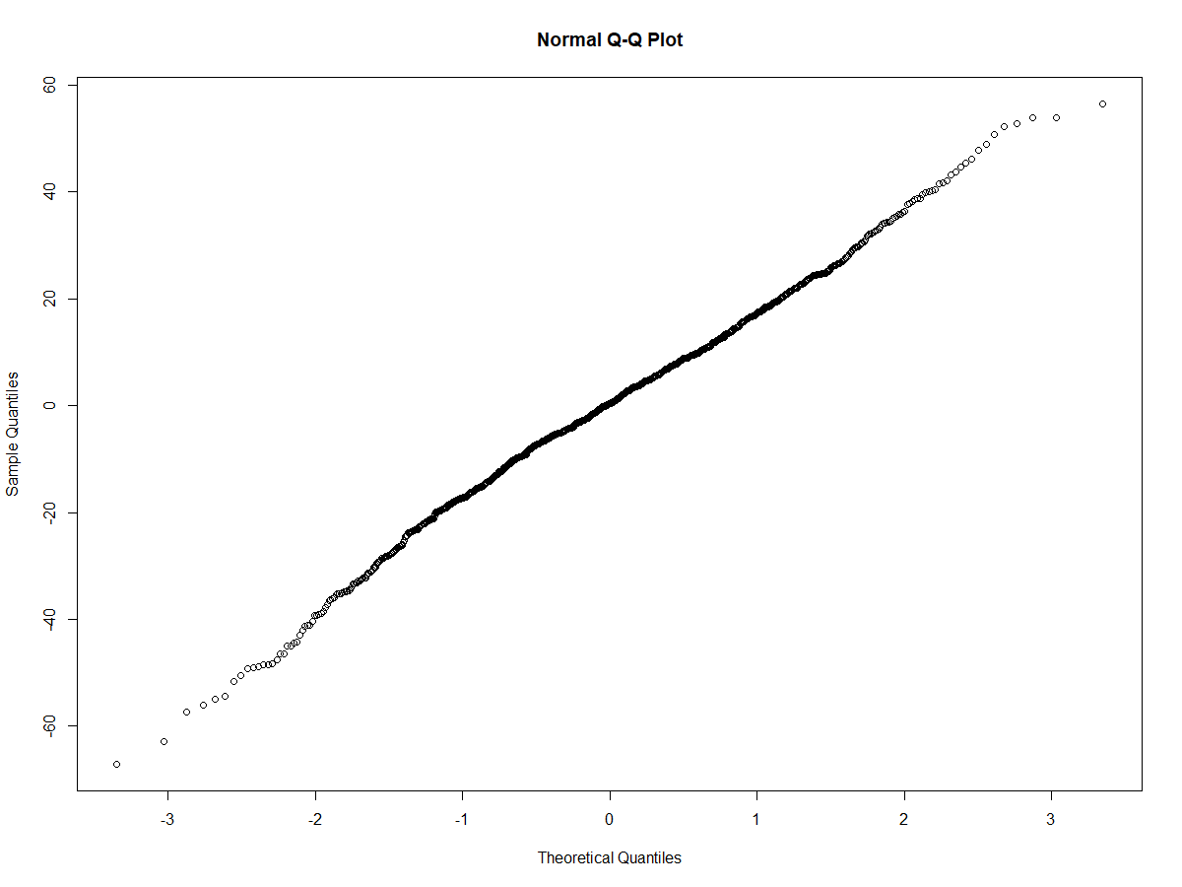

Normality test for the model – Parity and mother’s weight against baby weight, passes the test.

As far as the Durbin-Watson tests are concerned, the p-values for each model were:

* **Parity** and **mother’s weight** against **baby weight** = 0.0468
* **Mother’s weight and income** against **baby weight** = 0.046
* **Smoke and mother’s weight** against **baby weight =** 0.674

Clearly the autocorrelation in these models are either very insignificant or not present at all.

Even for the ncv test the p-values for the models were as follows:

* **Parity** and **mother’s weight** against **baby weight** = 0.03291
* **Mother’s weight and income** against **baby weight** = 0.11154
* **Smoke and mother’s weight** against **baby weight =** 0.43456

The tests show that there is heteroskedasticity in two models but one model does not have it present.

Appendix R code

# Fitting interaction models for certain variables against baby weight

# Linear model between mother's weight and smoking against baby weight

smoke_wt.1 <- lm(wt ~ smoke*wt.1, data = data)

summary(smoke_wt.1)

anova(smoke_wt.1)

# Linear model between mother's weight and parity against baby weight

parity_wt.1 <- lm(wt ~ parity*wt.1, data = data)

summary(parity_wt.1)

anova(parity_wt.1)

# Linear model between mother's weight and income against baby weight

inc_wt.1 <- lm(wt ~ inc*wt.1, data = data)

summary(inc_wt.1)

anova(inc_wt.1)

#Checking AIC scores for each model

AIC(smoke_wt.1)

AIC(parity_wt.1)

AIC(inc_wt.1)

# Error shape and distribution of model between mother's weight and smoking against baby weight

qqnorm(resid(smoke_wt.1))

shapiro.test(resid(smoke_wt.1))

hist(resid(smoke_wt.1))

# Error shape and distribution of model between mother's weight and parity against baby weight

qqnorm(resid(parity_wt.1))

shapiro.test(resid(parity_wt.1))

hist(resid(parity_wt.1))

# Error shape and distribution of model between mother's weight and income against baby weight

qqnorm(resid(inc_wt.1))

shapiro.test(resid(inc_wt.1))

hist(resid(inc_wt.1))

# Error spread of model between mother's weight and smoking against baby weight

smoke_resid <- resid(smoke_wt.1)

plot(fitted(smoke_wt.1), smoke_resid, ylab = 'residuals', xlab = 'Fitted values')

# Error spread of model between mother's weight and parity against baby weight

parity_resid <- resid(parity_wt.1)

plot(fitted(parity_wt.1), parity_resid, ylab = 'residuals', xlab = 'Fitted values')

# Error spread of model between mother's weight and income against baby weight

inc_resid <- resid(inc_wt.1)

plot(fitted(inc_wt.1), inc_resid, ylab = 'residuals', xlab = 'Fitted values')

# Error independence of model between mother's weight and smoking against baby weight

durbinWatsonTest(smoke_wt.1)

# Error independence of mother's weight and parity against baby weight

durbinWatsonTest(parity_wt.1)

# Error independence of model between mother's weight and income against baby weight

durbinWatsonTest(inc_wt.1)

# Ncv test for the models

ncvTest(smoke_wt.1)

ncvTest(inc_wt.1)

ncvTest(parity_wt.1)